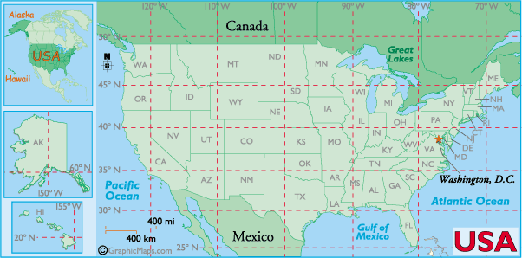

Identify the 3 states in the continental US that extend south of 30N latitude:
___________________________________________________________________________________
Identify the 3 states in the continental US that extend west of 120W longitude:
___________________________________________________________________________________
Identify the only state east of 70W longitude and north of 45N latitude:
___________________________________________________________________________________
Identify the only state that lies completely between 90W and 100W longitude, and 40N and 45N latitude:
___________________________________________________________________________________
The intersection of 40N latitude and 110W longitude can be found in what state?
___________________________________________________________________________________

